OS assignment # 3

2022360

Muhammad Bilal

Code:

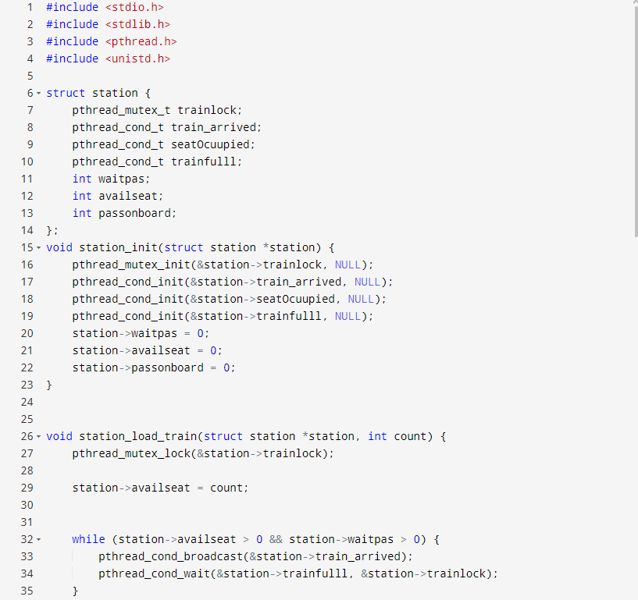

Output:

